Labyrinth

The Mayor of the rural town of labyrinth has commissioned a group of adventurers to explore the local dungeons. This is their story.

This is a game for 3-6 players, and 1 dungeon master.

V0.3.2

Table of Contents
Chapter 1: Character Creation 2
Chapter 2: The Decks of Cards 3
Encounter Deck 3
Items Deck 3
Card Levels 3
Chapter 3: Dungeon Building And Exploration 4
Stairs 4
Chapter 4: Combat 5
Character Death 5
Appendix A: Races and Racial Attributes 6
Human 6
Woodfolk 6
Oxkin 6
Hollow 6
Appendix B: Classes and Class Attributes 7
Archer 7
Medic 7
Warrior 7
Wizard 7
Appendix C: Encounter Cards 8
Custom Encounter Cards 8
Appendix D: Item Cards 9
Appendix E: Monster Statistics 10

Chapter 1: Character Creation

At the beginning of the game, each player rolls up a new character. Begin by choosing a race and a class. Each race and class has it's own effect on the generated statistics, as well as their own abilities.

The races are:

- Human
- Woodfolk
- Oxkin
- Hollow
The classes are:

- Archer
- Medic
- Warrior
- Wizard

There are three statistics used in this game. For each statistic, roll 3d6, then apply any race and class modifiers. The names of these statistics are:

- Strength
- Intelligence
- Luck

Once your base statistics have been determined, calculate the modifiers for each according to (S + T – 10) / 2 rounded down, where S is the base statistic, and T is the effects of any items you've collected and equiped. Each time that the base statistic changes, or you equip a new item, recalculate the affected modifier according to that equation.

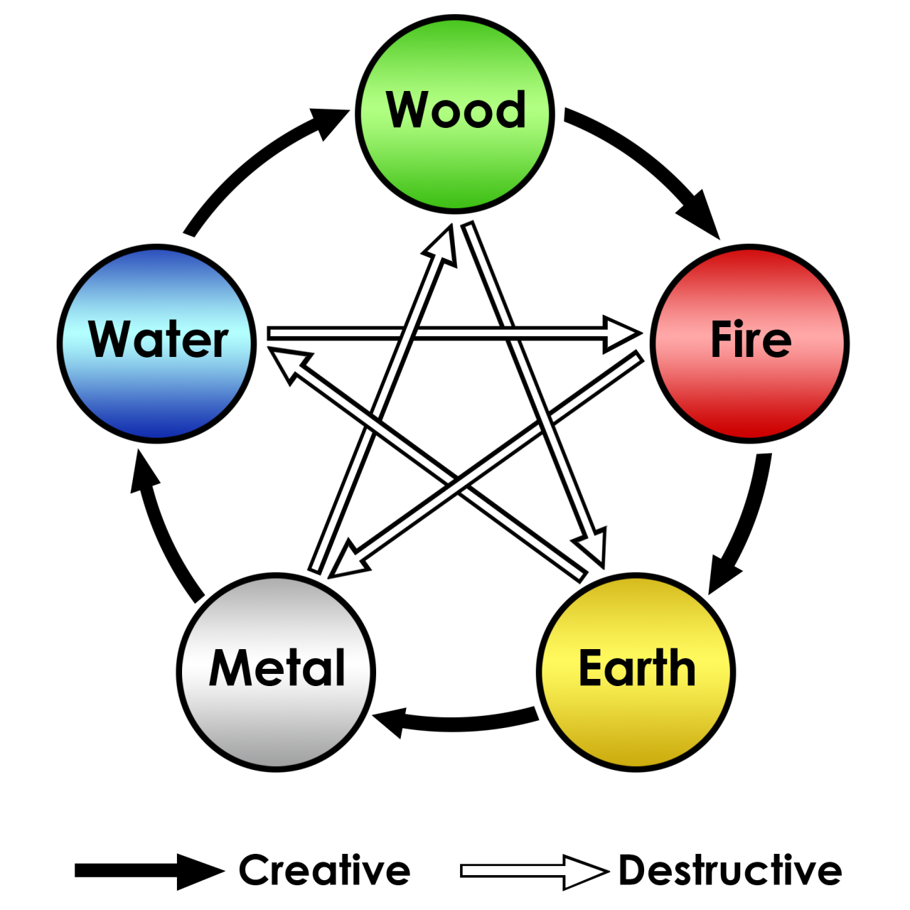
Next, choose an elemental affinity. Some races gain benefits from certain elements, while others give drawbacks. You can choose up to two elements from the diagram to the left, noting their relation to each other (either creative or destructive). If you choose just one or none at all, then the relation attribute is nullified.

Finally, each character begins with a maximum health point total based on their race, and 10 sliver pieces (or sp). This health point total resets to it's maximum when the players return to town.

Note: Although role play is only a light element of this game, it is encouraged. Choosing a back-story for your character, family members, etc. is a good idea before you start.

Chapter 2: The Decks of Cards

The game is played with two decks of cards. The first, the encounter deck, is used when the party enters a room. The second, the items deck, is used when treasure is found.

Encounter Deck

When the party enters a room in the dungeon, draw a card from the encounter deck, and follow it's instructions. The card represents what is found inside the room, be it a monster, a treasure chest, a trap or simply an empty room. Once the card is completed, it is placed in a discard pile, unless the card states otherwise.

Finding a monster, or a group of monsters begins a battle (see chapter 4 for combat). On finding a chest, the players may have to roll to see if it's trapped. In that case, follow the instructions on the card.

Finally, an empty room is a rare but welcome reprieve for the adventurers. A short rest can be taken here, wounds can be tended to, etc.

Items Deck

The items deck consists of a number of various different types of items, such as equipment, useless vendor trash, valuable treasures or cursed items. Up to three equipment cards can be “equipped” at once, granting boosts to your character. If an item is cursed, then it remains with the player that found it, applying a negative effect as though it was equipped, until they find a way to rid themselves of it.

When entering the market, the DM places three item cards face up. These cards can be purchased for their listed value. If an item is purchased, then another card from the deck replaces it. Items can also be sold for half of their value, rounded down; these are shuffled back into the deck. Cursed items can't be bought from the market, and are replaced when drawn this way.

Card Levels

Each card is marked with a level range, representing when a card should be added and removed from the decks. For example, a card with level 2-5 should only be played with between the levels of 2 and 5, inclusively. When a new dungeon level is entered, all cards in the discard piles should be shuffled back into the main decks, newly unlocked cards should be shuffled in, and cards that are too low level should be removed.

Chapter 3: Dungeon Building And Exploration

When you first enter a dungeon, you determine what floor you enter on. A party can only begin on a floor that they've previously unlocked by reaching it's entrance. Once a floor is unlocked, creatures and treasures of that floor's level are mixed into the decks of cards to represent that the new creatures are wandering around the dungeon. The first floor is automatically unlocked.

Each floor of the dungeon can have rooms up to the number of cards in the encounter deck. For instance, if you are playing a floor with 30 cards, than that room can have up to 30 individual rooms. When entering a new room, draw a card from the encounter pile and follow it's instructions. If it's a monster card, then combat begins. Once an encounter is finished, the room is considered empty.

Stairs

Some cards indicate that the players have found a stairwell. If this is the case, then the players have two options: they may return to the surface, or they may continue and unlock the next level of the dungeon. If the latter is chosen, then they must find another stairwell before returning to the surface.

Chapter 4: Combat

When combat begins, each player rolls a d20 to determine their turn order, called their initiative; whoever rolls highest goes first. The DM rolls a d20 for each monster type as well; all monsters of the same type share their initiative. If there are any ties, reroll the d20 to determine who among the tied participants goes first.

Combat is broken up into rounds, where each combatant takes a turn. Each combatant follows these steps when fighting.

- Choose a target to attack.
- Roll a d20, and add your strength modifier to the roll, plus any other appropriate modifiers; this is your attack roll.
- If the result is equal to or above the defender's armour class, then the attack hits, otherwise, your turn is over.
- If the attack roll hit, then roll another die based on your current weapon (your damage die) and add any other appropriate modifiers; this is your damage roll.
- Subtract the total from the defender's health points (HP). Once their HP is reduced to zero, then they are dead, and removed from the game.

Sometimes, a player will make a non-combat action, such as trying to bluff an enemy into submission, checking for traps or gambling in a back alley of the market. This is called an ability check, and is preformed like this:

- Choose an appropriate statistic; the DM decides if it's appropriate or not.
- Roll a d20, and add that statistic's modifier to the roll, plus any other appropriate modifiers.
- If you roll equal to or above a certain target number (10 for easy tasks, 15 for moderate and 20 for hard tasks; or the DM can et the difficulty themselves), then you succeed in your attempt.

It's generally encouraged to rollplay any attacks or ability checks, where possible.

Character Death

When a character dies, all item it owned are shuffled back into the item deck, and it's money is lost.

Appendix A: Races and Racial Attributes

Human

Health Points: 20
Armour Class: 10

Humans are the baseline race. When creating a human, each base stat is increased by 1. They also get another +1 in each stat if their elemental alignments are creative, or +2 to attack when their alignments are destructive.

Woodfolk

Health Points: 17
Armour Class: 10

Woodfolk are spirits of the forest, with bodies made up of the plants that they protect. As a result, they gain +2 to armour class when their elemental alignment includes either wood or earth; these bonuses don't stack. They also gain +4 to their maximum health points when their elements are creative.

Unless the woodfolk's elemental alignment includes water or metal, they take double damage from fire based attacks.

Oxkin

Health Points: 25
Armour Class: 12

Oxkin are a strong and proud race of oxen-line minotaurs. As such, they get +2 to Strength and +1 to the two other stats when their elemental alignment includes metal or earth; these bonuses stack.

If an oxkin's elemental alignment is destructive, then these bonuses are nullified, but they get the attribute “renegade”, and can attack twice in one turn.

Hollow

Health Points: 20
Armour Class: 8

Hollows are ethereal humanoids, which are rarely seen. It's possible that their race is going extinct.

When defending against an attack, if their elemental relation is nullified (one or zero elemental alignments), then they may add 2d6 to their armour class. If they do, then they skip their next attack.

Appendix B: Classes and Class Attributes

Archer

Unarmed Attack Modifier: +0
Unarmed Damage Die: 1d4

Archers attack their targets from afar, and as such are generally not on the front line. Archers receive +2 to their armour class.

Medic

Unarmed Attack Modifier: +0
Unarmed Damage Die: 1d4

Medics are experts when it comes to treating injuries. When you or an ally uses a card to regain Health Points, roll 1d6. On a 6, that card is not expended.

Warrior

Unarmed Attack Modifier: +0
Unarmed Damage Die: 1d6

Warriors function best when they are unburdened by the modern world. If you have no items equipped, your attack modifier becomes +4.

Wizard

Unarmed Attack Modifier: +2
Unarmed Damage Die: 1d4

Wizards channel the magic of the natural world to great effect. Instead of adding your strength modifier to attacks, you may add your intelligence modifier. If your elemental affinity is destructive, take 1d4 damage after you attack.

Appendix C: Encounter Cards

Here is a list of basic encounter cards to use to get a feel for the game as a whole. Appendix D also has a number of item cards that can be used. These appendices do not represent the full list of cards available in this game, but just enough to give a feeling of what the full game should feel like when complete.

Card Name | Card Contents | Levels | Copies
Treasure Chest | There is a treasure chest in this room. When a players open it, roll 1d4. On a 1, it is trapped, and the player who opened it takes 1d4 damage. Otherwise you find 1d6 sp. | 1-5 | 3
Empty Room | This is an empty room. | 1-5 | 1
Goblin band | There are 1d4+1 goblins here.  Treasure: 1sp per goblin defeated. | 1-5 | 3
Bugbear Band | There are 1d4+1 bugbear here.  Treasure: 4sp per bugbear defeated. | 1-5 | 2
Giant Floating Eyeball | There is 1 giant floating eyeball here.  Treasure: 10sp for defeating the eyeball monster.  Stairs: If you defeat it, you've found a stairwell. | 1-5 | 1
Kobold band | There are 1d4+1 kobolds here.  Treasure: 1sp per kobold defeated. | 3-5 | 3
Trapped Doorway | For each player, roll 1d4. That player takes that much damage. Otherwise, treat this room as an empty room. | 3-5 | 1
Empty Room | This is an empty room. | 3-5 | 1
Goblin War Party | There are 1d6 goblins and 1 Bugbear here.  Treasure: 1sp per goblin defeated; 4sp per bugbear defeated. | 3-5 | 2
Kobold War Party | There are 1d6 kobolds and 1 Bugbear here.  Treasure: 1sp per kobold defeated; 4sp per bugbear defeated. | 3-5 | 2
Dire Rat | There is 1 dire rat here.  Treasure: 10sp for defeating the dire rat.  Stairs: If you defeat it, you've found a stairwell. | 3-5 | 1

Custom Encounter Cards

It's possible to create custom encounter and item cards, using what is presented here as an example. To create a “monster band” card, for example, select a monster from appendix E, and put “There are 1d4+1 X here.” on the card, where X is the name of the monster in question.

Then, add a reward based on the difficulty of the encounter. Finally, give the card a level range based on how difficult you expect the encounter to be.

Appendix D: Item Cards

Card Name | Card Contents | Cost | Levels | Copies
Rations | You may expend rations in an empty room to regain 1d4 health points. | 3sp | 1-5 | 5
Medical Supplies | You may expend medical supplies in an empty room to regain 3d4 health points. | 12sp | 1-5 | 1
Treasure Hoard | Each player gains 5sp. This card cannot be sold. | - | 1-5 | 2
Dragon Statue | You may roll a d6, and follow the instructions listed below. This card cannot be sold.  - You die  - you may increase a base stat by 1  - you must decrease a base stat by 1  - You may switch the value of your luck stat with another stat.  - Your maximum health points increases by 1d4 + your luck modifier.  - Your maximum armour points increases by 1d4 + your luck modifier. | - | 1-5 | 1
Cursed Ring | This item is automatically equipped, and cannot be removed without a wizard. A wizard can be found in town.  You lose 1 point from each stat. | 10sp to remove | 1-5 | 1
Kobold Knife | This equipment grants +1 to strength and -1 to intelligence.  Damage die: 1d6 | 5sp | 2-5 | 2
Brainsucker Stick | This equipment grants +1 to intelligence and -1 strength.  Damage die: 1d8 | 5sp | 2-5 | 2
Sureshot Shooter | This equipment grants +X to attack when equiped by an Archer, where X is your luck stat.  Damage die: 1d8 | 10sp | 2-5 | 1

Appendix E: Monster Statistics

(NOTE: The following data is raw and unbalanced. Care should be taken when using it.)

Animated Armour

Health Points: 33
Armour Class: 18
Attack Modifier: +2
Damage Die: 1d6
Levels: 4-5

Bugbear

Health Points: 27
Armour Class: 8
Attack Modifier: +2
Damage Die: 1d8
Levels: 1-5

Devil

Health Points: 14
Armour Class: 12
Attack Modifier: +0
Damage Die: 1d4
Levels: 4-5

Dire Rat

Health Points: 45
Armor Class: 11
Attack Modifier: +3
Damage Die: 2d6
Levels: 3-5

Dragon

Health Points: 60
Armour Class: 18
Attack Modifier: +4
Damage Die: 2d8
Levels: 5-5

Giant Floating Eyeball

Health Points: 30
Armour Class: 13
Attack Modifier: +4
Damage Die: 2d6
Levels: 1-5
Goblin

Health Points: 7
Armour Class: 15
Attack Modifier: +0
Damage Die: 1d4
Levels: 1-5

Goblin Mage

Health Points: 7
Armor Class: 10
Attack Modifier: -1
Damage Die: 1d6
Levels: 2-5

Kobold

Health Points: 12
Armour Class: 10
Attack Modifier: +0
Damage Die: 1d4
Levels: 1-5

Velociraptor

Health Points: 40
Armour Class: 16
Attack Modifier: +3
Damage Die: 1d8
Levels: 4-5

